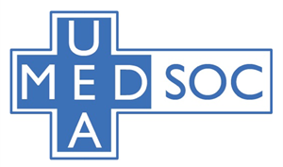
UEA MEDSOC CONFERENCE BURSARY FORM

Surname: ______________ Forename: ______________
Student number: ______________
UEA email address: ______________
Year you are in: ______________ If intercalating, please tick here: ____

Name of conference: ______________
Date of conference: ______________
How much money are you claiming? ______________ (£20 max.)
Please at least 2 photos of evidence e.g. ticket confirmation and bank statement

Declaration:

I declare that the information I have given on this form is correct and complete to the best of my knowledge, and that I have read the Terms & Conditions overleaf.

Signed: Date:

UEA MEDSOC CONFERENCE BURSARY FORM: TERMS AND CONDITIONS

- Students must be current and registered on a full-time undergraduate MED course at UEA (including foundation year) or be undertaking a one-year intercalation year of study during their MED course. Our committee will check all these credentials carefully before approving any fund.
- Application forms (in PDF) should be emailed to ueamedsoc1@gmail.com
- Approval of bursary claims are up to the discretion of the MedSoc committee and there is no guarantee of an award from an application.
- If a student withdraws from their course before the award is paid, their eligibility for payment immediately ceases.

March 2021

